MNIST Tanh:

Not normalized (images in 0-255):

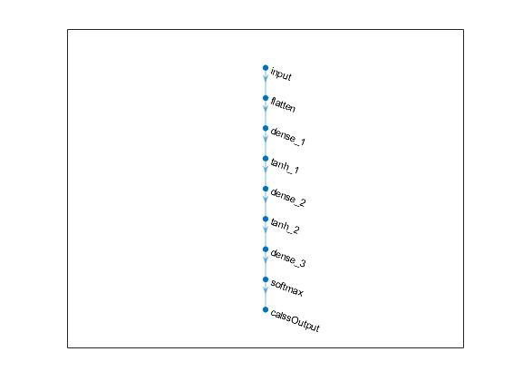

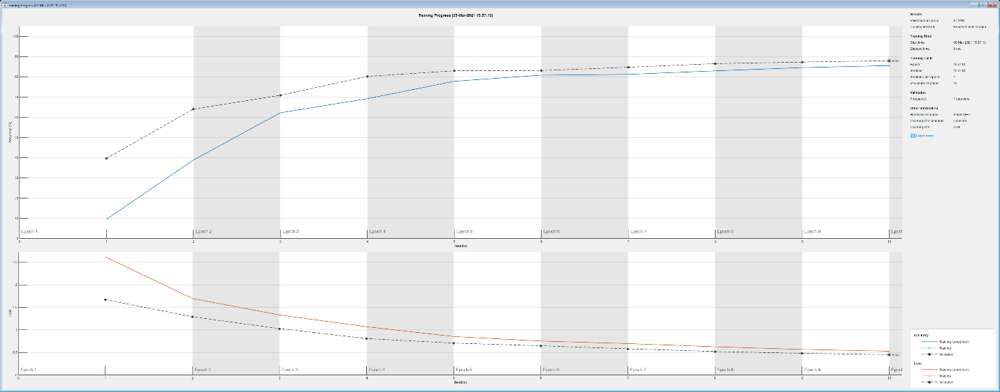

Validation accuracy: 87.89%

Test accuracy = 87.16%

MNIST Tanh:

Normalized (images in 0-1):



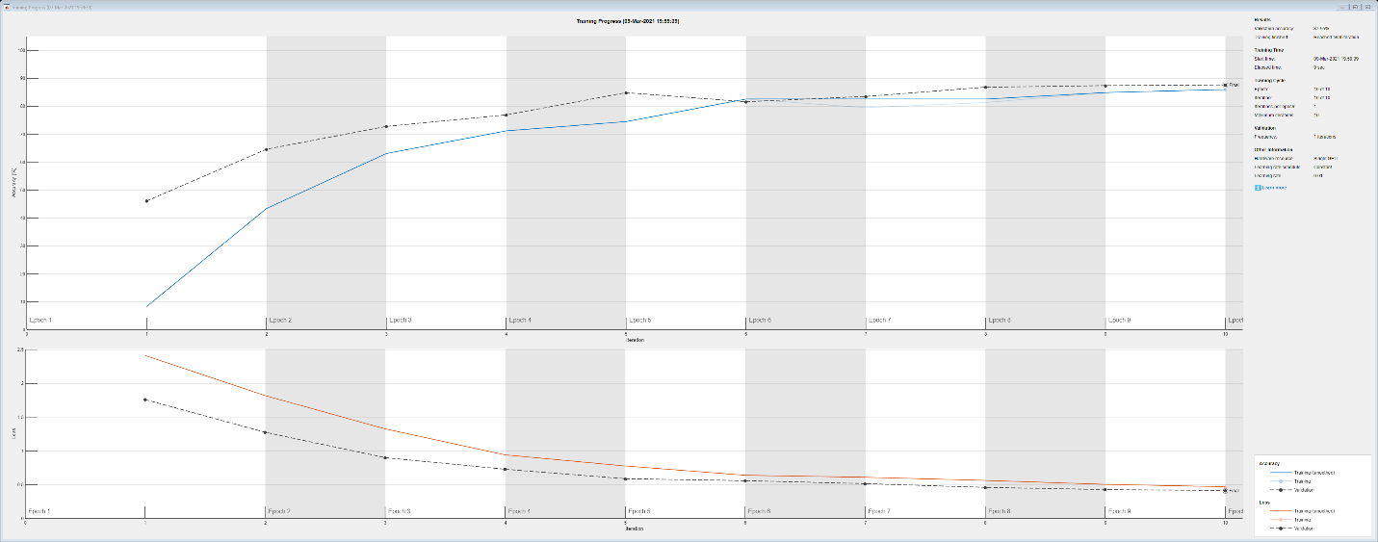

Validation accuracy: 87.55%

Test accuracy = 87.14%

